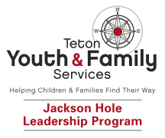

SCHOLARSHIP APPLICATION
The Jackson Hole Leadership Program provides scholarship opportunities for children who are in need and qualify financially. To be eligible for a full or partial scholarship, please complete the following information sheet. All information will remain confidential.

Child’s Name ___________________________________________________

Parent/s Name/s ________________________________________________

E-mail Address(s) _______________________________________________

Best Contact Phone Number__________
JHLP Program (circle one): Phase I Phase II

Cost of Program _____________ Total Funds Requested _____________

Please provide a brief explanation of your reason for requesting assistance: ______________________________________________________________________________________________________________________________________________________________________________________________________________________________________________________________________________________________________________________
Organizational Referral Name + Phone #:____________________________

I certify that all of the information submitted in this form is true.

_____________________________ __________________________________________
Signature Print Date

