Thanks for your interest in the Jackson Hole Leadership Program 2021! Phase I of the Jackson Hole Leadership Program (JHLP) is open to all boys and girls in Teton County ages 9-11. This is a day program (with one overnight camping trip) in which children participate in a variety of games, team-building initiatives and fun outdoor activities. Our focus is to create a fun and meaningful summer opportunity that builds leadership, self-confidence and positive decision-making skills through experiential activities in the outdoors to aid participants during their transition to adolescence. JHLP operates on a “Challenge by Choice” philosophy, allowing campers to take on challenges that they are comfortable with in a safe context.

All JHLP leaders are CPR and First Aid certified, and have been trained in facilitation and safety at the Ropes Course, as well as various activities and team-building initiatives.

Enclosed you will find an application and release forms for participation in this summer’s programming. Please submit completed forms and payment as soon as possible to secure your spot!

How to Submit
(We Recommend Online)
USPS Mail | Online | Drop Off
VAN VLECK HOUSE  JHLP  PO BOX 2631  JACKSON, WY 83001 | http://tyfs.org >  Van Vleck House >  Jackson Hole Leadership Program | Admin Office (Downstairs)  510 S. Cache St.  Jackson WY 83001

Please feel free to contact us with any questions that may come up during the registration process!
Phone: (307) 733-6440
Fax: (307) 733-6374
Email: leadership@tyfs.org

Registration Information

Full Participation
Each Phase I session runs for five days, with one overnight camping trip on the Thursday evening of each week. In hopes of building a strong group culture over the course of the session, we ask that you select a session in which your child is able to participate for all five days. If there is a foreseeable scheduling conflict with a certain session, we ask that you select a different week in which your child will be able to participate fully.

First-come, First-served Registration
In recent years, JHLP has grown significantly in popularity resulting in a competitive application process. There is a limited number of spaces available in each session, and these are offered on a first-come, first-served basis. Registration materials will be processed in the order that they are received.
Given the limited number of spaces and in hopes of making our program available to as many participants as possible, we can offer each child a space in no more than one session of programming per summer.

Choosing a Session
On the attached program application forms, we ask that you select your top three choices for sessions and rank them numerically (1, 2, and 3). If your first choice session reaches capacity prior to the time that your registration is processed, we will do our best to place your child in the second or third choice sessions.

Session Confirmations
There is a minimum number of participants that must register in each session in order for it to run. Once this number has been reached we will send out a message to all registered participants confirming your registration in the specified session.

Waiting List
With high volumes of registrants and a limited number of available spaces in each session, there may be instances in which we are unable to secure a space for your child in a specified session. If this is the case, we will maintain your application and contact information and add your child to a Waiting List for your session of choice. If there is a cancellation in the specified session, registrants on the Waiting List will be offered the space in the order that their application materials were received.

Cancellations
In registering for a particular session, we ask that you be certain your child will be able to participate in it. Once you have registered and received confirmation of your child’s space in the session you can cancel at no cost up until 30 days prior to the start date of that session. If you cancel after those 30 days your money will NOT be refunded. Concessions may be made in the case of medical issues or family emergency. Please contact the Program Coordinator in these situations.
Payment Information

The Jackson Hole Leadership Program (JHLP) offers fun summer experiences in the outdoors for more than 160 young people each year. The purpose of JHLP is to improve children’s lives by helping them develop interests and skills while forming strong positive peer relationships.

We would like to continue to keep this program affordable and accessible to all families. In order to do so we ask that you reflect on what your family can afford and make a decision on the amount you will pay based on that. We do receive generous donations to help subsidize some of the cost to make this affordable to all families.

Why has an alternative cost been added to the Application Form?
By adding an alternative cost option, we hope to communicate the level of support each Leadership child receives and inspire families to support JHLP at Old Bill's Fun Run or other fundraising events.

Phase I Cost
Required Minimum Cost: $350
Actual Cost: $500

Please note that your choice of payment options will not influence your child’s admission to the program.

Scholarship Information
Many scholarships are available upon request, and we aim to serve all children who wish to participate. Please do not hesitate to apply, regardless of financial situation. In order to request a scholarship, please include the completed Youth Scholarship Request form with your registration materials. This form can be accessed at the TYFS offices or on our website.

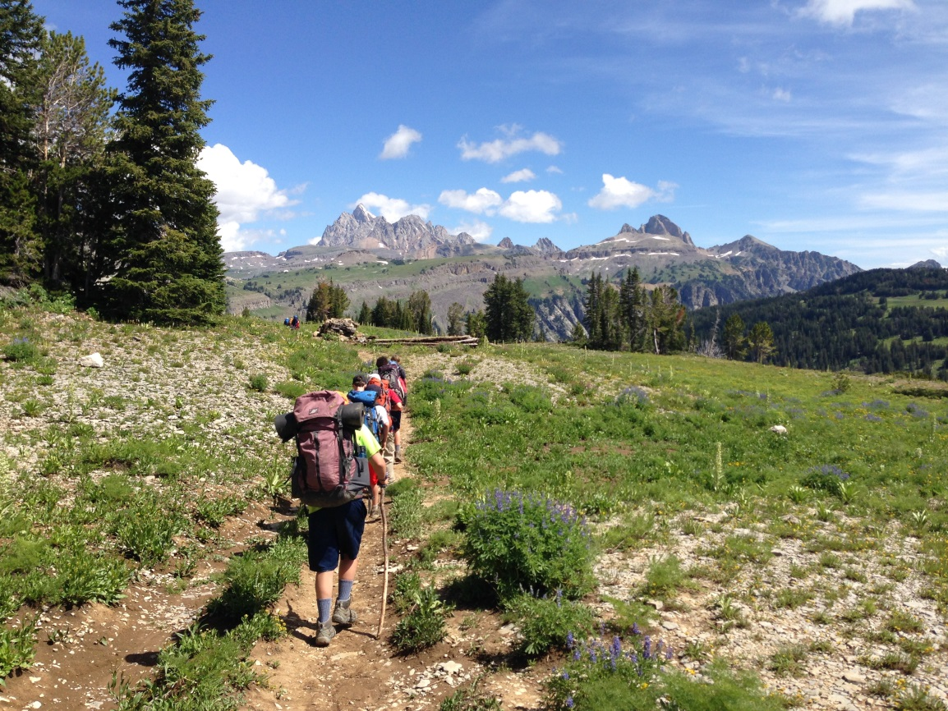

Jackson Hole Leadership Program 2020
Phase I Application

Please label your 1st, 2nd, and 3rd choices
____ Session 1: June 14-18 ____ Session 2: June 21-25 ____ Session 3: June 28- July 2
____ Session 4: July 12-16 ____ Session 5: July 19-23 ____ Session 6: July 26-30

Child’s Name ________________________________________________________________

Gender_______ Age______ Birthday____________ Grade in School (Fall 2021) ____________

Mailing Address______________________________________________________________

Parent/s Name/s_____________________________________________________________

E-mail Address/es____________________________________________________________

Best Contact Phone Number________________ Alternative Phone Number________________

Please Circle “YES” or “NO” to answer the following questions:

Has your child ever spent a night away from home (without parents)? YES NO
Does your child know how to swim? (circle one) YES NO
Does your child have any dietary restrictions? YES NO

If yes, please explain ____________________________________________________

Does your child have any allergies? YES NO

If yes, please explain ____________________________________________________

Are there any other concerns you would like to bring to our attention?

__________________________________________________________________________

__________________________________________________________________________

__________________________________________________________________________

If your child has a history of emotional, behavioral, family or school issues, please discuss them with a program leader prior to your session so we can best support your child’s needs.

Participation Consent

I/we, ___________________________, (parent’s name) as parent(s) and/or guardian(s) hereby give consent for _________________________ (child’s name) to participate in the Jackson Hole Leadership Program.

I am aware that the Teton Youth and Family Services, Grand Teton National Park, Bridger-Teton National Forest, or the Jackson Hole Leadership Program leaders may not be held liable for property destruction, injuries, or accidents that occur while my son/daughter is involved in any activities that are related to or sponsored by the Jackson Hole Leadership Program.

__________________________ ___________________
Parent/Guardian Signature Date

I request that my child’s photo NOT be used in future promotions for the Jackson Hole Leadership Program (program materials, brochures, etc.)

Payment

I will be paying the subsidized Phase I rate of $350.

I will be paying the full unsubsidized Phase I rate of $500.

I will be paying another amount: $ ____________________.

I will be applying for a full or partial scholarship and have included the appropriate forms with my registration forms.

Please note that your choice of payment options will not influence your child’s admission to the program.

Medical Consent

Consent and permission is hereby given for the Jackson Hole Leadership Program staff to obtain emergency care including anesthesia, surgery, hospitalization, or other treatment that may be deemed necessary. I understand that no procedures of an experimental nature shall be performed under this authorization. I also understand that every reasonable effort will be made to contact me before medical treatment is rendered.

The Jackson Hole Leadership Program staff carries the following over-the-counter medications to be used as necessary with the above-mentioned program participant: Ibuprofen, Benadryl, Children’s Pepto Bismol, Imodium A-D, and Claritin. All medications will be used as directed by the manufacturer. If you would prefer that your child not be administered any of these medications, please inform Jackson Hole Leadership Program staff.

Please note on the back side of this page if your child has any allergies or has medications to be administered by staff during the duration of the Jackson Hole Leadership Program.

Emergency Contacts (other than parents)

Name______________________________________ Phone___________________

Name______________________________________ Phone___________________

Name______________________________________ Phone___________________

Is youth limited to any physical activity? _______________ If yes, please explain:

___________________________________________________________________

___________________________________________________________________

___________________________________________________________________

___________________________________________________________________

___________________________________________________________________

Allergies: Please list all allergies, mild or severe, that your child experiences (medications, foods, bites, stings, etc.).

Allergy Reaction Medication

Medications: Please list all medications that your child is currently taking, including over-the-counter or homeopathic medications.

Medication Dosage Condition Side Effects

Parent Signature _____________________________ Date ______________

