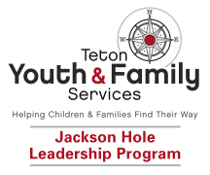

SCHOLARSHIP APPLICATION

The Jackson Hole Leadership Program provides scholarship opportunities for children who are in need and qualify financially. To be eligible for a full or partial scholarship, please complete the following information sheet. All information will remain confidential.

Child’s Name ___________________________________________________

Parent/s Name/s ________________________________________________

Mailing Address _________________________________________________

E-mail Address(s) _______________________________________________

Best Contact Phone Number__________

Alternative Phone Number __________

JHLP Program (circle one): Phase I Phase II Phase III

Cost of Program _____________ Total Funds Requested _____________

Please provide a brief explanation of your reason for requesting assistance: ______________________________________________________________________________________________________________________________________________________________________________________________________________________________________________________________________________________________________________________
Organizational Referral ____________________________________________

Organizational Contact Name ______________ Phone Number______________

I certify that all of the information submitted in this form is true.

_____________________________ ________________
Signature of Parent / Legal Guardian Date

_____________________________
Printed name of Parent / Legal Guardian

